The New York Browning Society, Inc. Newsletter
Founded in 1907
The National Arts Club  15 Gramercy Park South  New York NY 10003  Annual Holiday Poetry Reading  Wednesday, December 11  Time 1:00– 2:00PM |  | 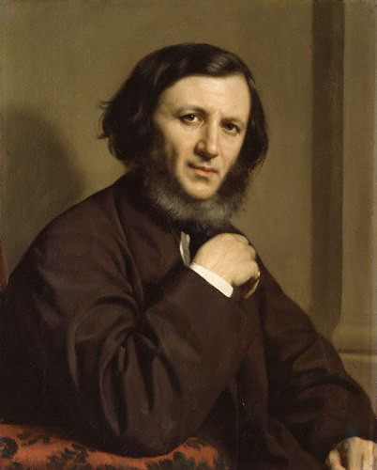
We hope that you will be able to join The Browning Society of New York and students from Clinton and Xavier High Schools for our annual poetry reading where members and guests will read poems by Robert and Elizabeth Barrett Browning.  Our annual poetry reading is an apt way to celebrate the holiday season since poetry held an important place in the Victorian celebration of Christmas. Illustrated poetry books were given as gifts at Christmas and were a focal point of domestic life. These beautifully designed books with ornamental gold and green covers became a popular commodity as a result of developments in the nineteenth-century printing press. As wood engraved blocks could be printed on letterpress at the same time as text, printers were now able to produce thousands of pages of illustrations without any deterioration of the image. This quick and easy printing process fueled a massive increase in illustrations in the nineteenth century and the illustrated Christmas book was one of the biggest markets. These books were intended for a growing middle-class | audience, who had more money to spend on luxury times, increased leisure time, and valued family and domesticity.  Illustrated Christmas poetry books fused high art with mass production to celebrate national greatness in art and literature. We can see this combination in David Bogue’s Christmas with the Poets: A Collection of Songs, Carols, and Descriptive Verses, Relating to the Festival of Christmas, from the Anglo-Norman Period to the Present Time, which was published in 1850 and included fifty-three illustrations by Birket Foster. Along with Charles Dickens’ illustrated Christmas books, Bogue’s work sough to align the festival of Christmas with the values and character of the British nation. That these books had national importance can be seen in the preface to Christmas with the Poets which states that, although not all the songs, carols, and descriptive pieces in the collection “merit the higher appellation of poem,” they “will be found to illustrate in some way or another an interesting by-gone custom, or to describe some feature worth preserving, connected
with the Christmas celebrations of our ancestors.”  The poems in Bogue’s Christmas with the Poets are arranged chronologically and divided into six sections: poems from the Anglo-Norman period to the reformation; poems of the Elizabethan period; poems by Herrick about Christmas; Christmas songs and carols from the Civil wars, Commonwealth and Restoration; Christmas poems from the eighteenth century; and Christmas poems from the nineteenth century. Selected poets from the nineteenth century include Southey, Wordsworth, Shelley, Coleridge, Hemans, Keble, and Tennyson, among others. The collection grandly closes with Tennyson’s poem “The Death of the Old Year.” While Christmas with the Poets celebrates poems and songs, it also provides explanations for historical Christmas traditions such as the decking of houses with holly and ivy and wassailing the apple trees.  The sheer amount of ornate Christmas books that were published in the nineteenth century as well as the popularity of these books as gifts and revered objects in the home demonstrates the importance that Victorians placed on recording traditions and customs. The burgeoning Christmas book market also reveals the ways in which Christmas was reframed by the popular printing press to define developing Victorian definitions of national identity.  We look forward to seeing you on December 11th for our annual holiday poetry reading. | 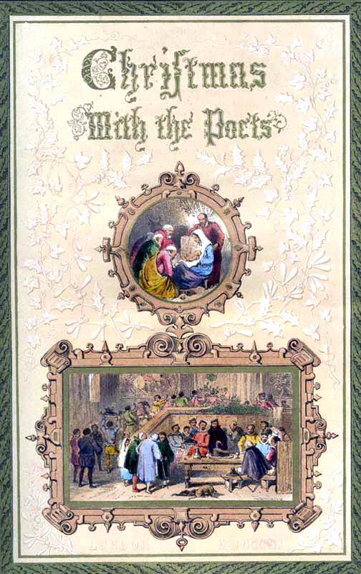  James Browning Kepple, President  Robert Kramer, Vice President  Tandy Cronyn, Treasurer  Laura Clarke, Corresponding Secretary  Nancy McGraw, Recording Secretary  Gene Bierhorst, Director-at-Large  KT Sullivan, Director-at-Large  Tom D’Egidio, Director-at-Large  Stephen Downey, President Emeritus

